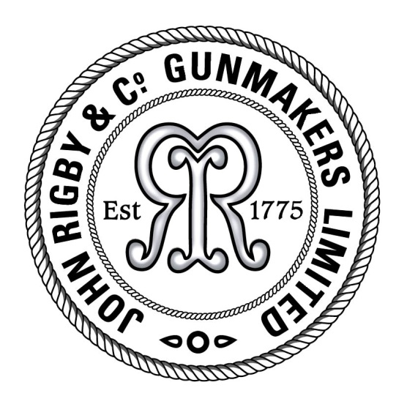
Press release
For immediate release

Rigby completes first .577 Rising Bite for more than a century

London gunmaker John Rigby & Co. has completed its first rising bite in .577 Nitro Express for more than 100 years. The double rifle was made for a valued client, who wished it to be a tribute to Satao, the famous Tsavo tusker. It includes an exquisite floorplate engraving of Satao himself by Rigby’s Finnish in-house engraver, Saija Koskialho.

According to Rigby’s historic ledgers, the last rising bite in this calibre to be produced at its workshop was in 1907. In addition to the image of Satao, the 2019 rifle also features a number of unique details on the trigger guard requested by the client, including a miniscule mouse and the rifle’s name.

The rifle’s new owner, who divides his time and hunting between his farm in Zambia and his native northern Europe, said: “I gave Rigby the time they needed and I’m delighted. I wanted the rifle built mainly as a tribute to Satao because I believe in conservation and I believe that hunting managed correctly is the best way to help wildlife and to deal with the increasing human-animal conflict.”

“We’re extremely proud to bring this project to realisation,” commented Rigby MD Marc Newton. “As always, we had a wonderfully supportive client and the results speak for themselves: it’s a beautiful gun that not only looks great but also handles superbly. At thirteen-and-a-half pounds, it’s light enough to carry it all day on safari but heavy enough that the recoil is very manageable.”

High res images can be found here: bit.ly/Rigby577

Editor’s notes:
- Founded in Dublin in 1775, the company has more than 240 years of gunmaking experience.
- Rigby opened its first London shop in 1865 and continued operating out of both offices until they closed their Dublin shop in 1897.
- The company moved to the USA in 1997, but returned to London in 2013 when it was bought by L&O Group, Germany.
- Rigby now operates out of a purpose built premise in Pensbury Place, London.
- In 2013, Rigby recommenced their historic partnership with Mauser, which dates back to the late 19th century.
- The firm manufactures bolt-action, double rifles and shotguns. Products of particular note include the iconic Rising Bite double rifles and shotguns, fully bespoke London Bests, the award-winning range of Big Game bolt-action rifles and the Highland Stalker.
- For media enquiries, email liz@tweed-media.com or telephone +44 (0) 1890 882441.

